Program Approach
Digital Program

Executive Sponsors: Jeff Wright, Azfar Karimuddin

Program Owners: Christina Mullin, Jason Bond

CWB Project Management Office
November 14, 2019

Document Information

Revision History
Version | Date | Authors | Revision Notes
1.0 | 11/14/19 | Madeleine Dery | First draft based on template

Review and Contributions
Version | Name | Role | Title

Contents
Document Information 2
Revision History 2
Review and Contributions 2
Introduction and Summary 4
Current Situation and Opportunity 4
The key goal of this program is to digitize the Account Opening processes and be a disrupter in offering unique Online Banking platform products and services for Small Business Owners. 4
Business Objectives and Strategic Alignment 4
Recommended Solution 5
Solution Overview 5
The People 1st Team 8
In Scope 8
Out of Scope 8
Proposed Milestones and Timelines 9
Benefits Realization 9
Cost Benefit Analysis 9
Critical Success Factors 9
Stakeholders 10
Risks 10
Review and Approval 12

Introduction and Summary

Current Situation and Opportunity

The key goal of this program is to digitize the Account Opening processes and be a disrupter in offering unique Online Banking platform products and services for Small Business Owners.

Business Objectives and Strategic Alignment
The Digital program supports the following key strategic objectives:

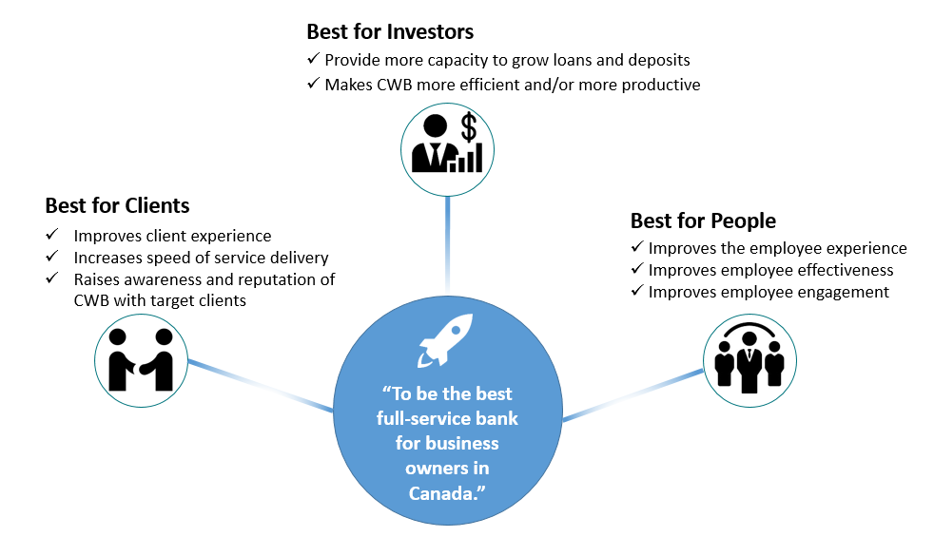
Best for Investors:
- Attracting new clients which will increase loans and deposits will benefit investors.
- Reducing manual efforts that are currently required to open new accounts will improve efficiency and productivity.
Best for Clients:
- The modern and distinct products that will be delivered by the Digital Program will improve client experience though improving the functionality of the online systems, and offering clients tools they don’t have access to elsewhere.
- Digital Account Opening will offer retail and small business clients a much faster way to open a new account remotely, which will benefits prospective new clients who are outside of CWB’s current geographic branch footprint.
Best for People:
- Reducing manual efforts required by CWB staff will improve the employee experience and allow them to focus on more value-add activities.
- Staff are clients of the bank, and will benefit from the improved experience that will be delivered by the retail changes in the Digital Program, and in particular the enhancements to personal online banking.

Recommended Solution

Solution Overview

Program Approach
The Digital Program will deliver the following solutions as project phases, using a core program team of shared resources:
- Motive Digital Account Opening
- Personal Digital Account Opening
- Branch Personal Digital Account Opening
- Small Business Banking Platform (Including Digital Account Opening for Small Business)
- Branch Small Business Digital Account Opening
- Corporate Digital Banking Platform
- Personal Digital Banking Platform
- Motive Lending
The benefits of a program approach are:
- Utilizing a common resource pool will allow the team to build their expertise in the technologies being implemented and enhanced, which will create efficiencies for each subsequent delivery, from lessons learned.
- Developing and executing consolidated People First plans will allow the team, to provide streamlined tactics such as communications and training to.
- Allowing the Project Owners and Executive Sponsors to oversee multiple phases concurrently, using the same governance structure (eg, meeting schedule) will save them time over managing projects separately.
- Sharing vendor technologies and resources among the project phases will result in efficiencies.
- Sharing a common budget will limit the number of requests in the annual budget process.
- Project status reporting at CWB can be streamlined to a program level view.
A Program is …..
“A group of related projects managed in a coordinated way to obtain benefits and control not available from managing them individually.”
~ PMI.org Oct 2018
Program Governance Framework
Establishing an effective governance framework is critical and will enable the success of the program. Program Governance addresses the following needs:
- Continuous linkage to enterprise business strategy and direction  - Decisions appropriately aligned with organizational objectives and principles and they are occurring at the appropriate level  - Clear and well-understood decision-making authority and accountability  - Effective oversight of and insight into program progress and direction  - Executive insight and decision control over program evolution and outcomes  - Enablement and tracking of benefits realization  - Program progress, risks and issues are being effectively managed | Executive  Steering Committee  Sponsor Oversight Group  Program Owners  Direction and Decisions  Options and Analysis
Program Governance Roles & Accountability
Executive Steering Committee
The Executive Steering Committee will be made up of Executive and Sr. Management stakeholders who are given authority and accountability for setting strategic direction for the program, defining key success metrics, prioritization (time, scope, budget) and monitoring the program.
Sponsor Oversight Group
Executive Sponsors from Client Solutions and Information Services, who have the authority to make decisions and recommendations, will ensure the program delivers on the enterprise requirements and defined success criteria.
Program Owners
The Program Owners are the lead people accountable to the Executive Sponsors and the Executive Steering Committee for the success of the program. The Program Owners have the overall accountability for program delivery, including scope, budget, schedule, resources and stakeholder management. The Program Owners will report directly to the Executive Sponsors and will be the Chair of the Program Advisory Group.
Program Advisory Group
The Program Advisory Group will consist of VP and AVP level members, along with operational managers who will provide input to the program and support decision making as required.
Program Management
The Digital Program will be managed by the Program Owners. High impact change requests will be presented to the Program Advisory Group for recommendations and the Executive Steering Committee for decision.
Program Governance & Delivery Framework
The following diagram shows the relationship between Program Governance and Program Delivery. This chart is available in the first Executive Steering Committee Meeting presentation deck.
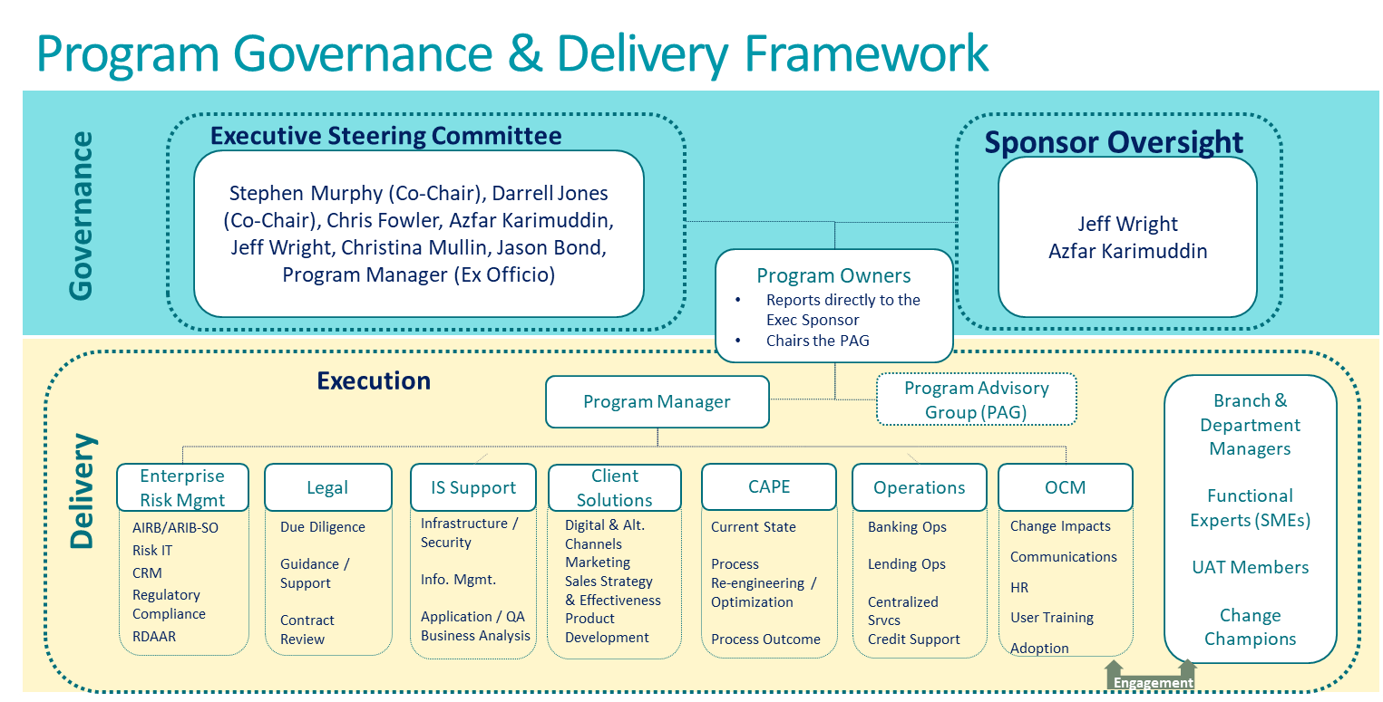
Program RACI
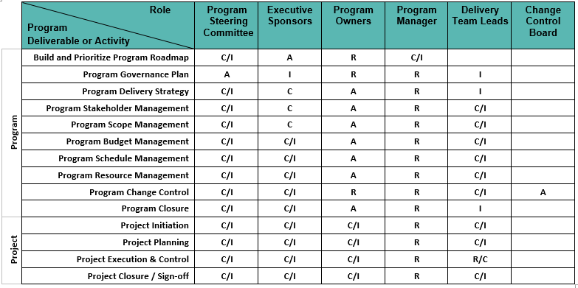

The People 1st Team
The Digital Program will leverage the trained resources relevant to the disciplines of Change Management, Communication, Learning and Development and Marketing as part of a People 1st Team.
People 1st Delivery
The Digital Program will consist of several project phases logically sequenced to meet the overarching objectives of the program. Each phase will have its own set of change impacts, audiences and timing. To reflect this, the People 1st engagement and deliverables will take an over-arching program approach, as well as plan and execute specific tactics specifically for each phase.
Regardless of the size and complexity of each change, People 1st will leverage the Prosci® change management process and the ADKAR change model as documented below:
Go-Lives ->

PMO Framework | Solution Design &  Detailed Business Solutions Articulated
OCM Framework
To ensure alignment between the two models and to enable a more streamlined project reporting, OCM will leverage an iterative approach to OCM deliverables (i.e. “living deliverables”) that allow for the creation of ‘checkpoints’ on upstream and downstream dependencies, milestones and deliverables. These checkpoints will provide snapshots into the status and health of the change management plans and activities, inserted at points that directly align to the PMO standard. It is anticipated that many of the larger project phases under the program will observe formal stage-gates and that the Change Team will actively contribute to these readiness (go/no-go) gate decisions.
All People 1st activities will be coordinated and aligned with the Sr. Mgr. Organizational Change Management serving as the responsible party.

In Scope
The detailed scope of the project phases that are listed in the Solution Overview section above will be defined in more detail at the start of each phase, and detailed business requirements will be identified for each.

Out of Scope
The following items are considered to be out of scope for the Digital Program:
- Changes to current products such as CWBdirect online banking and CWBdirect Business Online Banking, and Cash Management products such as CAFT, Remote Deposit Capture and CWB Wires, unless otherwise defined in the phase scope statements.

Proposed Milestones and Timelines
The following are the major program milestones and timelines identified at this time. As the program planning moves forward and the schedule is developed checkpoints will be established to confirm the milestones and their target completion dates.
Milestone | Activities | Target Completion Date
Program Initiation | Establish detailed program scope  Identify key stakeholders  Identify program benefits  Preliminary risk assessment  Develop Program Charter  Develop high level resource plan  Establish program governance | November 29, 2019
Digital Account Opening Planning | Identify detailed scope and Business Requirements  Develop detailed schedule  Develop detailed resource plan  Program kickoff  Create budget tracking  Develop Program Management Plan | January 10, 2020
Digital Account Opening Execution | Confirm detailed design and architecture  Complete development and unit testing  Execute end-to-end System Integration Testing  Plan and execute User Acceptance Testing  Conduct Pilot for Motive friends and family  Launch Motive DAO to the public  Launch Personal DAO | November 1, 2020

Benefits Realization
Benefits will be documented in detail for each project phase of the Digital program.

Cost Benefit Analysis
The FY20 budget for the Digital Program will come from:
Source | Amount
Capital | $3,600,000
NIE | $3,400,000
TOTAL | $7,000,000

Critical Success Factors
In order for the Digital Program to be successful the following conditions must exist:
- Resources: The Digital Program will require the involvement of several teams and resources, some of which need to be dedicated to the program full time. Subject Matter Experts must have a specific level of knowledge and experience and must be available at specific times during the program.
- Leadership: To manage the business process review, leaders who understand the solution and the impacts of change will be needed at all levels from executive to administrative. Executive Sponsors and Program Owners must provide visible, demonstrable and sustained endorsement.
- Priorities: The Digital Program must be regarded as a high-level priority. Conflicts between the Digital Program and other projects or operational work activities may impact the success of the Digital Program.
- Effective Decision Making: The decision making structure must be agile, accessible and responsive to the complex needs of the Digital Program. Decisions must be made in a timely manner and in the clear context of enterprise level goals and objectives.
- Communications: Communications is the lifeline of complex change. Sustained and focused communication to all stakeholders throughout the Digital Program, but in particular ensuring alignment of all of the vendors is critical to the success of the design, architecture and builds, to be reflected in the end-to-end integration testing, deployment and then sustainment.
- Methodology: CWB and the Digital vendors must find a way to align various methodologies, from waterfall to agile, in order to reliably deliver the business requirements defined.
- Sustainment: There must be resources allocated to sustainment of solutions beyond project closure or operational implementation.
- Compliance: Continual engagement with Regulatory Compliance must take place to ensure that all solutions are compliant with all regulations for consumer protection and fraud protection. This will mitigate significant risks to the project success as well as to CWB’s reputation and bottom line.

Stakeholders
The Digital Program is a complex undertaking that impacts numerous and diverse groups of stakeholders. The following table represents the primary Stakeholder groups that will play a continual role throughput the Program. A detailed NI-RAP will be completed for each project phase to identify additional Stakeholders for engagement.
Stakeholder Group | Role on Project | Level of Program Engagement  (H\M\L) | Level of Operational Impact (H/M/L)
Banking Operations | Program Delivery | M | L
Branches/Regional Management | Program Delivery | M | L
Branch Staff | SME / UAT Support | L | M
Client Solutions | Program Governance & Delivery | H | H
Corporate Communications | Program Delivery | M | L
Information Services | Program Governance & Delivery | H | M
Motive Financial | Program Delivery | H | H
Organizational Change Management | Program Delivery | H | L
Program Management Office | Program Governance & Delivery | H | L
Regulatory Compliance | Program Delivery | M | M

Risks
The following are the preliminary risks that have been identified at this time. A more detailed risk analysis will be conducted for each of the project phases. The program will maintain and actively manage a Risk Log and Program risks will be communicated in the Program status updates.
 | Inherent Risk |  |  | Residual Risk
Risk Category & Details | Probability | Impact | Mitigation Strategy | Probability | Impact
Schedule - timelines are at risk of delays due to the time required to resource the projects; this is due to vendor and CWB availability, the length of time to complete the CWB/vendor procurement processes, unexpected vendor delays, all with limited/no contingency available with the current target dates. | H | H | Schedule risks will be mitigated primarily through clear communications internally about the high prioritization level of the program. Additionally, strong communications will be required to identify availability issues and potential delays early enough to minimize impact. | M | M
Quality – the quality of vendor deliveries is at risk; this would result in more time needed to stabilize through testing/defect fixes than planned. | M | H | Quality risks will be mitigated by conducting detailed reviews of business requirements, design and architecture documentation to ensure that the deliveries will meet expectations. In addition, the agile approach used by the vendors will allow for early reviews of the builds to be able to evaluate quality early enough to make adjustments if required. | L | M
Vendor – this is the first time the vendors are implementing this solution with this architecture. This creates uncertainty. | M | H | Vendor risks will be mitigated by ensuring close alignment of vendor activities from the start, including weekly meetings together and apart, as well as collective reviews of requirements and design deliverables. Early identification of any misalignment between vendor designs will allow for changes earlier in the project. | M
Delivery Model – the ability to move project work fast through a matrix environment of shared resources will be limited vs. dedicated delivery teams | H | H | Delivery risks will be mitigated by supplementing resources as much as possible to ensure full availability of key resources needed. | M | M
Resourcing – Within the current agile program structure, core and support teams are still being defined and sourced with many unknowns to validate. | H | H | Resource uncertainty risks will be mitigated as scope and design are further defined, to aid in the identification of any gaps. | M | M
Budget – ability to keep to targeted budgets is at risk already as the estimates have not proven accurate. | M | M | Budget risks will be mitigated through early and frequent reviews of any variances that get identified. | L | L

Review and Approval
The signatures of the people below indicate they have an understanding of the Program purpose and content documented in this Program Approach. The signatures provide the necessary approvals for the proposed Digital Program to proceed on delivering the solution.
Approver | Title | Signature | Date
Jeff Wright | Sr VP, Client Solutions
Azfar Karimuddin | VP, Information Services
Christina Mullin | VP, Digital and Alternative Channels
Jason Bond | Sr AVP, Application Services
Kenneth Mastaller | Sr AVP, Program Management Office

